This android app initially displays a list activity containing previously saved entries (the list is blank if no entries were saved previously). It features a Create icon and an Options menu in its action bar.

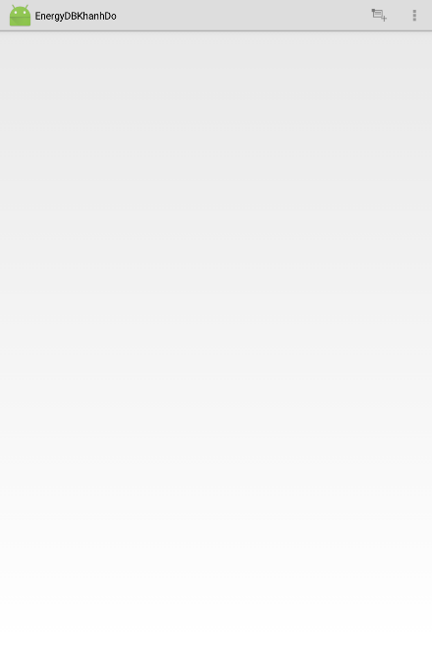

Figure 1

The user may click on the Create icon in the action bar to launch an activity shown below. The rating bar is set to five stars and time button displays the current time by default. The rating can be changed from 0 to 7 stars in 0.5 increments.



Figure 2

When the time display button (on the upper left of the screen) is clicked, a time dialog appears from which the user may change the time.

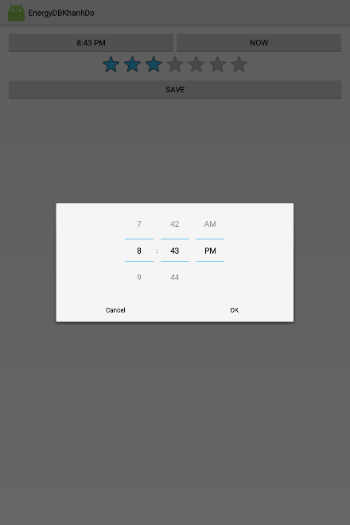

Figure 3

Clicking the “NOW” button resets the time button to the current time. Clicking the “SAVE” button will save the entry to the list activity. Clicking the device’s back button will launch the home screen which displays the saved entry/entries. 5 entries were entered and saved for this demonstration. Each entry contains the rating, date and time (set to military time).

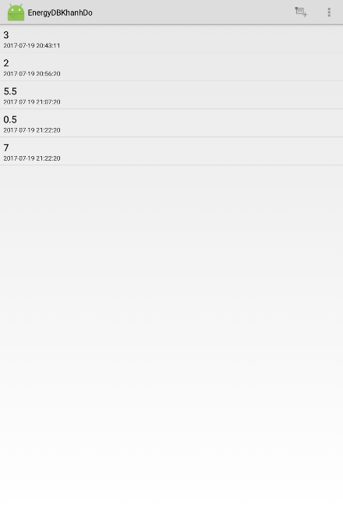

Figure 4

The user may click on the options menu to bring up two features: Summary and Delete All.

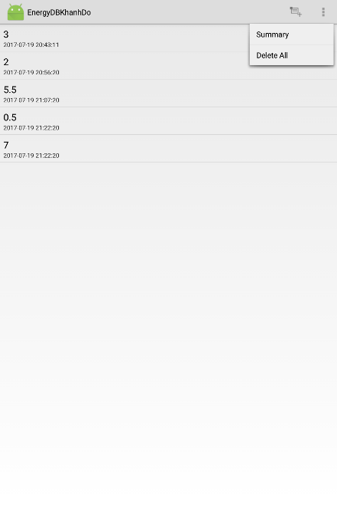

Figure 5

Clicking on the Summary option will lauch a summary page which contains the number of entries and the average rating of the entries.

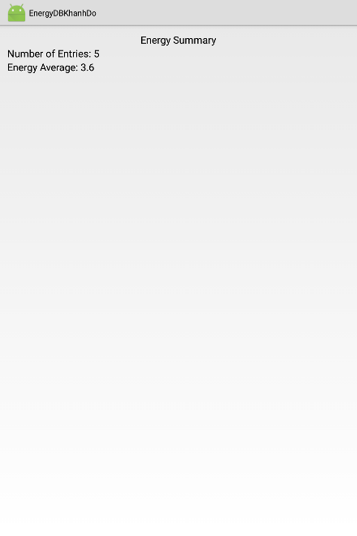

Figure 6

Clicking on the Delete All option will erase all of the saved entries. The home screen will be blank when the user returns to it by clicking on the device’s back button.

A long click on any item will bring up a context menu with a feature to delete the rating.

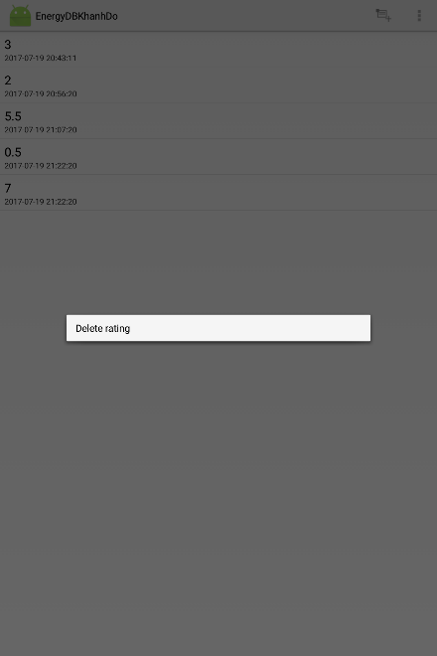

Figure 7

Clicking the “Delete rating” context menu item will remove the selected item. The first item was long-clicked and deleted for this demonstration.

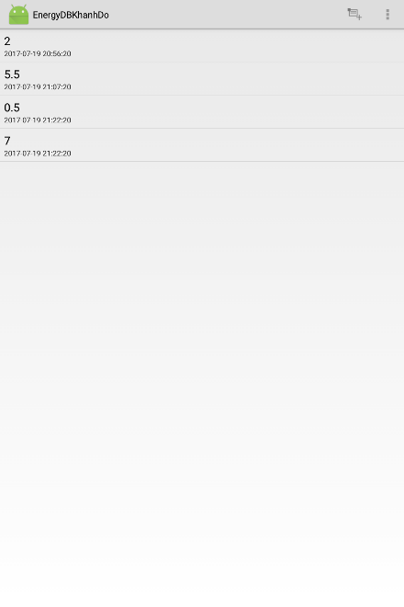

Figure 8

Short clicking an entry will launch the edit activity screen. This screen will have the settings set to the rating and time values of the selected entry. The user does not edit the date. The second entry (5.5 rating) was clicked for this demonstration.



Figure 9

Changed the time or rating and the item will be edited upon saving. (Changed rating to 3.5, time to 10:50 pm. Clicked the device’s back button.)

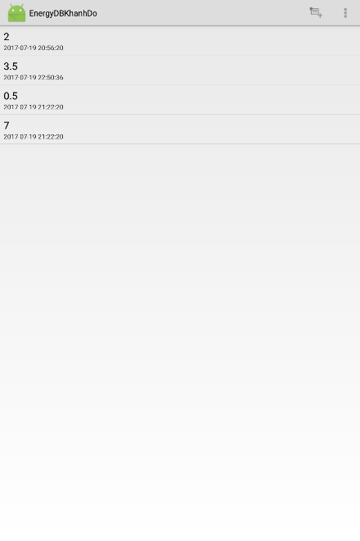

Figure 10

Rotated the device and the home screen appears intact.

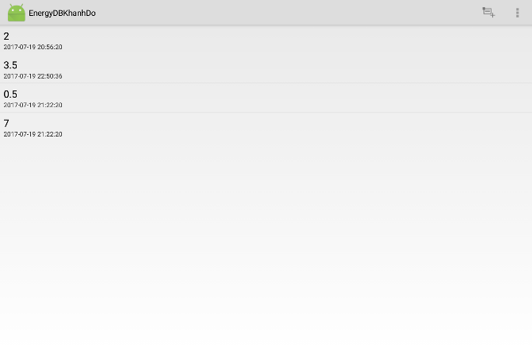

Figure 11

Rotated the device back to the usual vertical position. Short clicked on the first item to bring up the edit screen. This create/edit screen also remains intact upon rotation of the device.

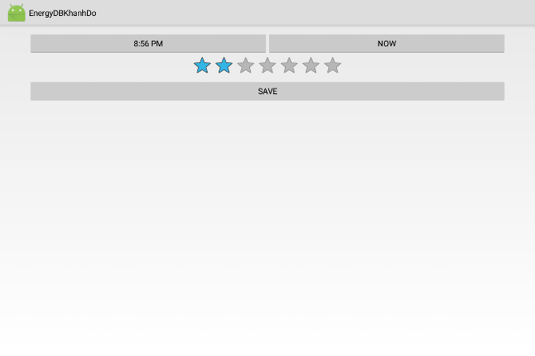

Figure 12